Class Assigmnent
Programming
Name:-Jeevan Rajpurohit
Student ID=202312090

1).
#include<bits/stdc++.h>
using namespace std;
int summ(vector<int>& nums, int threshold)
{
int n = nums.size();
int left = 0, right = 0;
int sum = 0;
int maxSize = 0;
while (right < n)
{
sum += nums[right];
while (sum > threshold)
{
sum -= nums[left];
left++;
}
maxSize = max(maxSize, right - left + 1);
right++;
}
return maxSize;
}
int main()
{
vector<int> nums = {4, 5, 2, 1};
vector<int> queries = {3, 10, 21};
vector<int> answer;
for (int i = 0; i < queries.size(); i++)
{
answer.push_back(summ(nums, queries[i]));
}
for (int i = 0; i < answer.size(); i++)
{
cout << answer[i] << " ";
}
return 0;
}
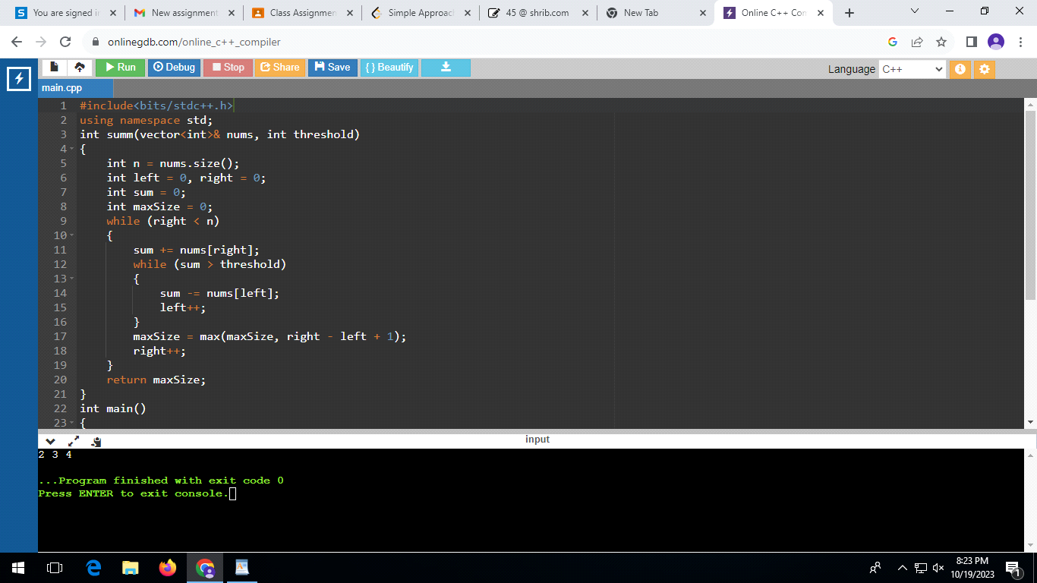

2).
#include <iostream>
#include <vector>
using namespace std;
int searchInsert(vector<int>& nums, int target)
{
int left = 0;
int right = nums.size() - 1;
while (left <= right)
{
int mid = left + (right - left) / 2;
if (nums[mid] == target)
{
return mid;
}
else if (nums[mid] < target)
{
left = mid + 1;
}
else
{
right = mid - 1;
}
}
return left;
}

int main()
{
vector<int> n1 = {1, 3, 5, 6};
int t1 = 5;
int r1 = searchInsert(n1, t1);
cout << r1 << " ";
vector<int> n2 = {1, 3, 5, 6};
int t2 = 2;
int r2 = searchInsert(n2, t2);
cout << r2 << " ";
vector<int> n3 = {1, 3, 5, 6};
int t3 = 7;
int r3 = searchInsert(n3, t3);
cout << r3 << " ";

return 0;
}

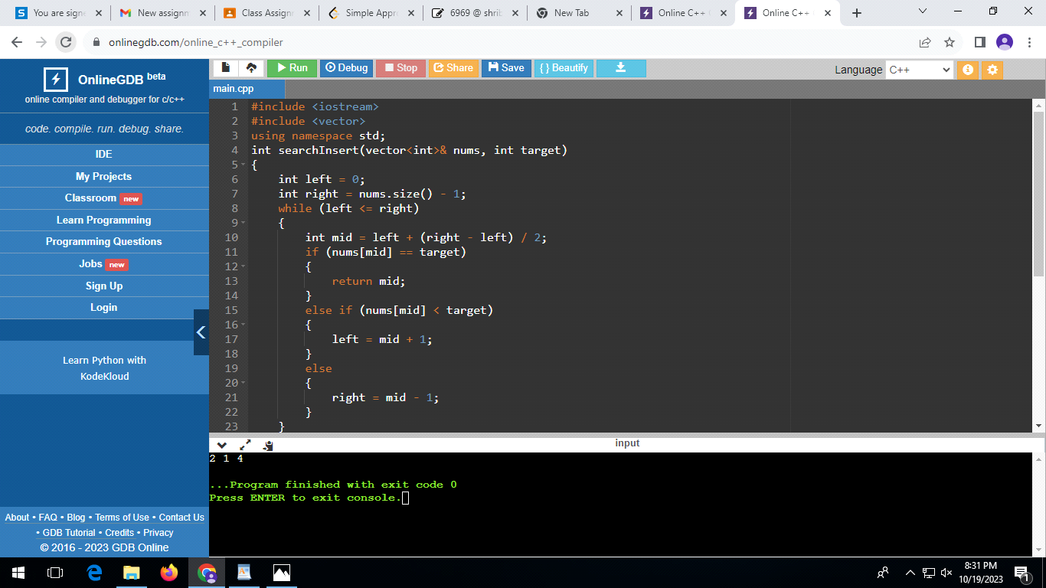
3).
#include <iostream>
#include <vector>

using namespace std;

int missingNumber(vector<int>& nums) {
int n = nums.size();
int missing = 0;

for (int i = 0; i <= n; i++) {
missing ^= i;
}

for (int num : nums) {
missing ^= num;
}

return missing;
}

int main() {
vector<int> nums1 = {3, 0, 1};
cout << "Missing NO.: " << missingNumber(nums1) << endl;

vector<int> nums2 = {0, 1};
cout << "Missing No.: " << missingNumber(nums2) << endl;

vector<int> nums3 = {9, 6, 4, 2, 3, 5, 7, 0, 1};
cout << "Missing No.: " << missingNumber(nums3) << endl;

return 0;
}
